***HOW TO GET STARTED WITH FREELANCING***

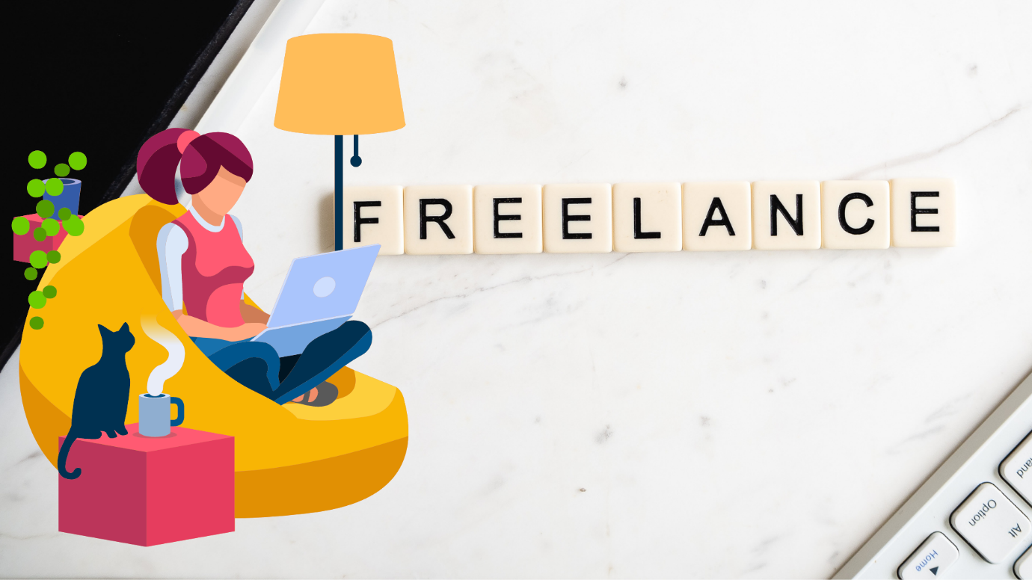

**What do you understand by a Freelancer?**

**A Freelancer is a person who does particular piece of work for the different organisations, rather than working all the time for a single organisation.**

**This refers to working independently usually for the various organisations rather than as an employee of a particular organisation.**

**Fields, professions, and industries where freelancing is predominant are- music, writing, acting, computer programming, web design, graphic design, translating and illustrating, film and video production, and in some other fields as well.**

**STEPS TO START FREELANCING-**

**-FIND A MARKETABLE SKILL- The first step comes is to find that in what kind of skill you are good at. If you are good at Graphic Designing or Web Development then you can move further with it as your skill and present it in the market.**

**-POLISH UP YOUR SKILLS- Whatever skill you are good at get it polished first and then move further. Practice well regarding the skill.**

**-BUILD YOUR REPUTATION- You should have worked prior on the skill that you are good at. If you are good at Logo Designing then you should point out and tell that you have designed the logo of that reputed brand.**

**-CREATE A PORTFOLIO- A portfolio can be a website or a webpage where you showcase all your work. You should make a portfolio of your work or skill set. So that the clients come to know about your work.**

**-TRY PART-TIME FREELANCING- Firstly you should try part time freelancing. Because of it you should not compromise with your job. You can keep freelancing as a part time work.**

**-FIND THE RIGHT FREELANCE PLATFROM- A mistake most beginning freelancers make is that they search for the most popular freelance marketplace and join the first one they find to get started. Do not go for the platforms where everyone goes as they can make you work for a low amount then instead go for the platform where you can get a middle range pay.**

**-CHARGE THE RIGHT PRICE- In the beginning, the best way to figure out the right price is to go look at popular freelance marketplaces and see what other freelancers in your industry are charging. Instead, you should try to figure out a middle-ground where you can offer a competitive price than those experienced freelancers.**

**-COMMUNICATE WELL-** **Communicate well with your clients as the first expression is the last expression. You should try to be respectful with your clients and in return you will get the same.**

**-SEND YOUR FIRST PROPOSAL-** **Whatever work you have done till now you should showcase it in order to tell your clients that how your work actually is.**

**-DELIVER BEYOND EXPECTATIONS- Once you get a job, the next step is to make sure that you deliver the project just as the client has asked. Try to deliver your best.**

**CONCLUSION-**

**Freelancing is a good career choice for many professionals, but it depends on the goals, financial situation, and risk tolerance. The most difficult year people face as a freelancer is the first year. It gets easier after that. So freelancing is a very good long-term career choice if you are willing to make a career in it.**